**Japan: Non-Tariff Barriers to Apple Trade**

**(The fruit apple)**

**Introduction**

The tariff barriers, in the form of duties, have declined in most developed countries. Meanwhile, the non-tariff barriers have increased substantially.

A non-tariff barrier, by definition, is a way to restrict trade using trade barriers in a form other than tariff.

Non-tariff barriers are much harder to reach and can more easily be camouflaged. The effect can be more far-reaching because they are difficult to calculate and are much more unpredictable. Some of the most common non-tariff barriers are as follows;

* Licenses
* Quotas
* Embargoes
* Levies
* Sanctions
* Voluntary Export Restraints

Now that we know what non-tariff trade barriers are, let’s discuss the case of Japan’s imports of apples from the USA and the several unconventional ways exporters were restricted from selling their produce in Japan.

**(U.S Apple exports from 1962 to 2016)** 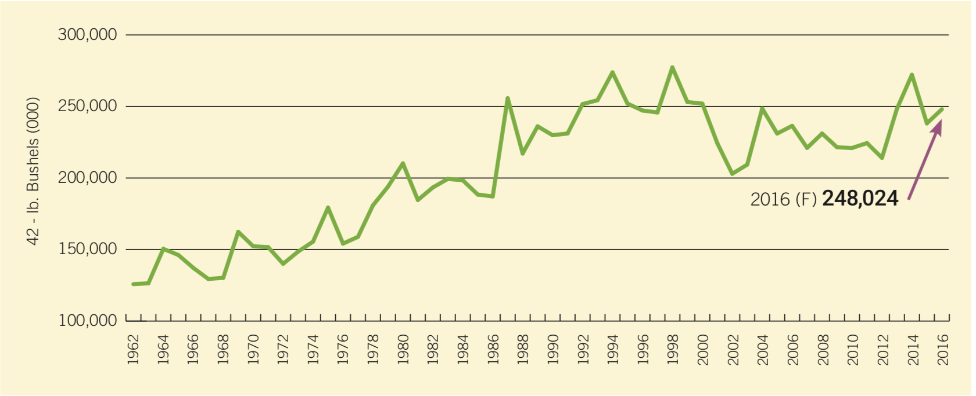

The United States is one of the world's largest fresh apple exporters.

In the 1996/97 marketing year, for instance, 24% of U.S. fresh apples were exported. While many varieties of apples are produced in the United States, Red and Golden Delicious remain the most common, accounting for an estimated 56% of the U.S. crop. (2014)

Fresh produce can, however, harbour diseases and insects which could survive shipment and endanger production in other countries.

Most countries accept U.S.A’s systems approach to disease and pest management for apple exports as an adequate precaution to protect their domestic industries.

The systems approach uses a combination of risk- eliminating measures (Good commercial production practices, grading, sorting, visual inspection) which cumulatively reduces the risk of the target diseases or pests to an insignificant level.

Now Japan is a major apple producer too, famous for its high-quality fruit, **but largely isolated** from world apple markets.

Japan’s fruit Imports X axis- years ,Y-axis- Yen(in millions)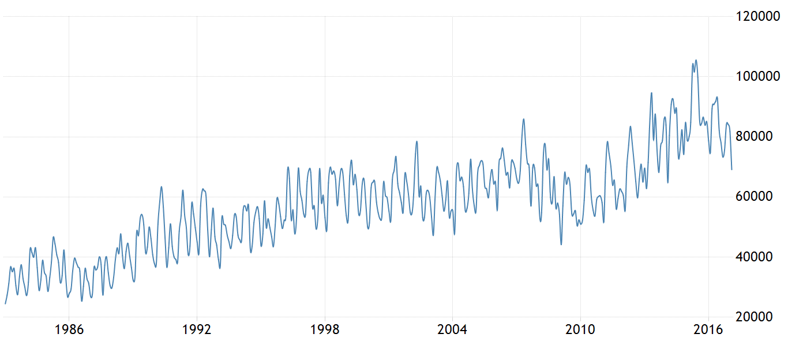

In 1994, Japan lifted it’s long standing ban on imports of U.S. apples and ban on 13 types of U.S. apples and authorized imports of Red and Golden apples under phytosanitary requirements. If you see the graph, Japan’s imports of fruit has only increased from 1993 on and never gone below 40000 million yen.

This decision had followed the 1993 threat by U.S. Trade Representative to impose general trade sanctions over Japan if the issue was not resolved.

The Japanese phytosanitary requirements on apple imports are commonly viewed as the most restrictive and rigorous of any country, short of an outright ban.

Japan is allegedly concerned with the spreading of fire blight, codling moth, and apple maggot. Only U.S. Red and Golden Delicious apples are allowed into the country because tests of the effectiveness of quarantine treatments have been completed for these two varieties.

It’s the inspections for fire blight which are the costliest portion of the apple export program. The United States, however, has shown that there is no scientific evidence that mature apple fruit can transmit fire blight.

The WTO panel and Appellate Body sided with US on this issue.

This ruling reinforces one of WTO's basic rules – health and safety requirements must be based on sound science.

"We are committed to ensuring a level playing field for apples and other agricultural goods. U.S. apple growers have suffered from Japan's unwarranted import requirements which were imposed with no scientifically sound justification," said the then U.S Agriculture Secretary, Ann Veneman.

**Japan’s Restrictive Measures**

Japan claims that it’s apple production areas are free of fire blight, thereby justifying its rigorous regulations regarding the disease. (Untrue, however, a bout of fire blight was reported in the country in 1930.)

Certain restrictive practices form non-tariff barriers for apple imports from US to Japan.

**#1** For imports, Japan required a chlorine dip as one of several precautions against fire blight.

**#2** U.S. growers who wanted to export apples to Japan also had to register their land in advance for the Japanese protocol, and had to comply with all requirements.

**#4** The inspections had to occur at bloom time, just prior to harvest when a Japanese inspector must also be present. The Japanese inspector examines every tree in an orchard block that is registered for the export program for any evidence of fire blight.

**#5** Further, the area had to have a 500-meter buffer zone with no pear trees or other natural hosts for fire blight. This buffer zone then also is inspected. **If fire blight is found in the orchard or buffer zone area, all apples in that orchard block are banned from export to Japan** for the season.

**#6** Growers registered for the export program were compelled pay the inspection costs.

**#7** The certification of approval had to be renewed annually.

Estimates put the likelihood of an outbreak of fire blight, under the current export protocol for Japan, to be one outbreak in every 38,462 years. In comparison to this, based on only the standard export procedures used for trade with most countries, the likelihood of an outbreak is 1 in 11,364 years.

**Decreased trade due to these barriers**

During the 1994/95 season (the very first year of apple trade with Japan), U.S. exports of Red and Golden apples to Japan totalled 8,497 metric tons. Growers enrolled more than 2,406 acres in the export program in the first season (with 2,508 acres in the buffer zones). Since then, **exports of apples to Japan have declined drastically.** (trade of apples decreased) and no apple growers registered their acreage for the 1997/98 crop year. Limited demand for Red and Golden apples in Japan in addition to the costly and risky phytosanitary requirements have led to lower profit in exporting to Japan than originally anticipated.

Following talks in June 1997, the United States and Japan failed to reach a mutual agreement, and the United States called for a WTO dispute panel to resolve the issue. In October 1998, the WTO ruled that Japan's variety testing procedure violated it’s WTO obligations.

**Conclusion**

Having compared results before and after 1993(year when Japan lifted tariffs on apple imports from USA) I believe non-tariff trade barriers in Japan are even more important than tariffs in deterring trade. Moreover, the **primary role of Japanese Trade Barriers for apple imports appears to be to protect economic rents of it’s own domestic producers from foreign competitors and not to maximize social welfare**. There are many identical examples of regulatory measures by domestic producers who exert strong influence to maintain Trade Barriers that protect economic rents. Local apple exports have been increasing since 2005, thus signifying a growing domestic industry. One would think that the sole reason for such “regulation and scrutiny” and consequent rejection is to foster growth of it’s domestic production and providing employment to it’s own people.

I assumed, here, that world prices are not affected by the changes in Japanese imports. The estimated large increases in Japanese imports if barriers were eliminated, however, would likely have had an impact on world prices. If this were to take place the Japanese prices would not decline as much, and the disease loss required to eliminate the consumer gains would be less.

**Bibliography**

Graph1- <http://usapple.org/wp-content/uploads/2016/09/2016ProductionUtilizationAnalysis.pdf>

Graph 2 – [www.TradingEconomics.com](http://www.TradingEconomics.com)

<https://www.wto.org/english/tratop_e/dispu_e/245rw-1_e.pdf>

<https://atlas.media.mit.edu/en/>

<https://www.wto.org/english/tratop_e/dispu_e/cases_e/ds245_e.htm>

<http://usapple.org/wp-content/uploads/2016/09/2016ProductionUtilizationAnalysis.pdf>

**Roll:24**

**Div.A**

**********************